|  |  |  |  |  |  |  |
| --- | --- | --- | --- | --- | --- | --- |
| VILNIAUS KOLEGIJA  UNIVERSITY OF APPLIED SCIENCES  FACULTY OF ELECTRONICS AND INFORMATICS  Image result for viko logo | | |  | | | VILNIUS COLLEGE  Image result for viko logoFACULTY OF ELECTRONICS AND INFORMATICS |
|  | | |  | | |  |
| **BUSINESS MANAGEMENT SYSTEMS** | | |  | | | **INTRODUCTION TO INFORMATICS** |
| PRACTICAL ASSIGNMENT  TASK4  6531BX028 PI18E | | |  | | | PRACTICAL ASSIGNMENT  SPOTIFY USER MANUAL  6531BX028 PI18E |
| STUDENT | SAULĖ STANKEVIČIŪTĖ | STUDENT | | DŽIUGAS PEČIULEVIČIUS |
| (SIGNATURE)  3/18/2020 | | |  | | | LECTURER |
| LECTURER | TATJANA LIOGIENĖ | (SIGNATURE)  10/17/2018 | | VIRGILIJUS KUKLIERIUS |
| (SIGNATURE)  3/18/2020 | | |  | | | 2018 |

2020

**TABLE OF CONTENTS**

Introduction 3

Goal 3

Requirements 3

Programs used 3

Description of organization’s activities 4

Selected modules 5

Module functionality 7

Invoicing module 7

Inventory module 9

Purchases module 9

Sales module 10

Website and eCommerce modules 10

Configured odoo modules 14

Conclusion 15

# Introduction

## Goal

The goal of this practice work is to familiarize ourselves with odoo system, analyse the modules we are using and explain the implementation purposes as well as the functionality all the while applying it to the business system that is described in the organization activities section.

## Requirements

* Title sheet;
* Content;
* Introduction (purpose of the work and tasks to achieve it (steps of pw1));
* Description of the organization's activities (Presentation of the organization with its activities (services, products); Zero-level DFD with description);
* Suggested ODOO modules (name of module and justification why it is offered to this organization);
* Detailed description of modules (demonstrating modules with sample data, pictures, description);
* Conclusions.

## Programs used

<https://www.odoo.com/>

<https://app.diagrams.net/>

# Description of organization’s activities

The purpose of this plant show is to offer the clients an easy and user-friendly way of picking out the most desired and best fitting plants. The scale of products that the shop offers ranges from indoors plants to outdoors vegetation. The company keeps contact with third-party suppliers to offer a plethora of products to satisfy the most exquisite interests the customers might have.

Image 1 shows the 0 level DFD on how the internal structure of the company works. Table 1 explains more about how each of the shown processes contribute to the overall functionality of the company. A screenshot of a cell phone

Figure 1 – 0 lvl DFD

Table 1 – process description

|  |  |
| --- | --- |
| **Process name** | **Process description** |
| ACCOUNTING | Managing company’s money. Takes it into and out of the bank. Accounting department provides office a report on how company is doing money-wise and similar statistics. |
| ADMINISTRATION | The head of the company.  Gathers reports from all other departments, manages human resources, planning and distributing instructions to other departments. |
| SALES | Keeps track of the order information. Gathers what customers prefer to buy and reports the data to the administration. Processed order information goes to product warehouse where the items can be shipped to the customer, or, if need be, ordered from the supplier. |
| PRODUCT WAREHOUSE | Responsible for product shipment, inventory management and communication with the supplier. Distributes products according to order information, sends reports to accounting and administration. |

# Selected modules

Table 2 - Selected Modules

|  |  |
| --- | --- |
| **Module** | **Description** |
|  | The plant shop company needs a module to organize the warehouse. This module has simple user interface, keeps track of every stock move and provides clear and complete reporting and dashboard. |
|  | The sales management module allows to better showcase the products and services, as well as allows to send polished quotation with e-signature and online payment without much trouble. |
|  | Invoicing management makes billing way easier. This module allows to bill automatically based on SO, delivery orders, contracts or time and material. Simplifies the accounting. |
|  | Purchase management module improves the supply chain and inventory performance. Automatically sends RfQs to the supplies based on the stock levels. Helps with refund managing and product receivals, as well as quality control. |
|  | Website builder module helps the user to create a fully functional website with integrated marketing stack by using drag and drop to implement business features. |
|  | eCommerce module provides ability to create appealing, mobile friendly product pages with marketplace integration, personal customer portal and shippers integration. |

# Module functionality

## Invoicing module

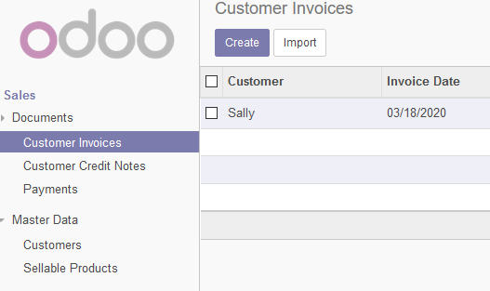

Figure 2 - Invoicing module 1

Allows to see customer invoices, create new ones, import from external source, and manage existing ones.

This module also provides information on master data. One part of it is customers:

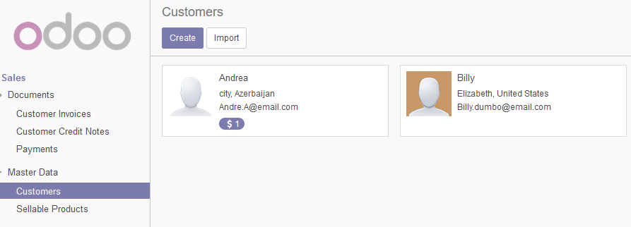

Figure 3 - Invoicing module 2

Another part is sellable products:

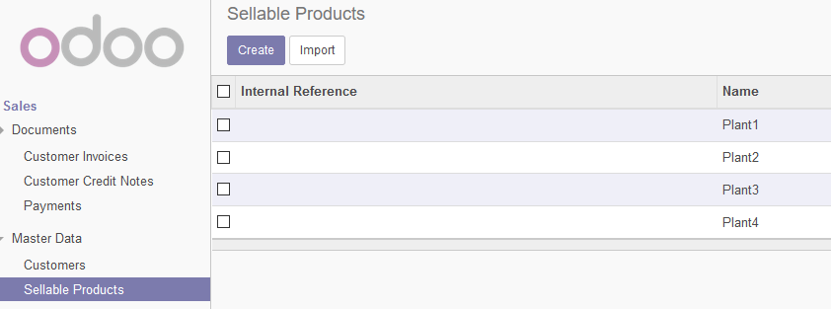

Figure 4 - Invoicing module 4

It shows all the products that the system database has, allows simple product management.

It also allows to track purchase information with master data of vendors and purchasable products:

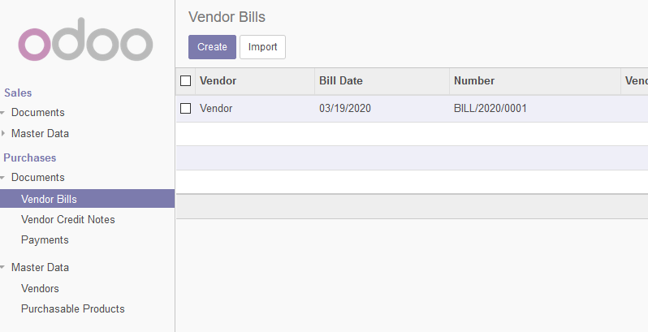

Figure 5 - Invoicing module 5

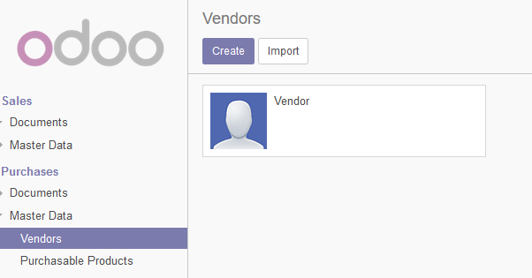

Figure 6 - Invoicing module 6

This is valuable tool for this company, since plant shop has to communicate with the customer as well as with the supplier, and module provides all the necessities for that.

## Inventory module

Another very useful module for this company is inventory management. Since the shop has a product warehouse, a proper way of managing the import, export and storage is crucial. The module provides a variety of operations, for example, transfers adjustments and scrapping items from the stock. It also allows access to master data, like the invoicing module, but with additional functionality of operations, reporting and configuration groups, this module provides a more effective inventory management.

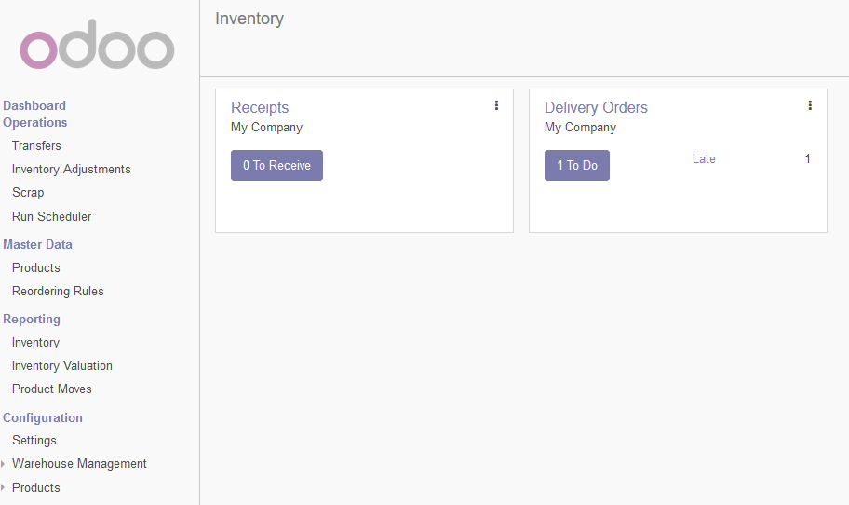

Figure 7 - Inventory module

## Purchases module

This module provides tools to create quotations that contain the history of the discussion/negotiation between the company and the vendor. It is very important to have smooth transactions with no lose ends and to have documented course of purchase. Once the quotation is confirmed, it is converted into a purchase. This module is good for efficient negotiations with vendors and purchase tracking for the company. 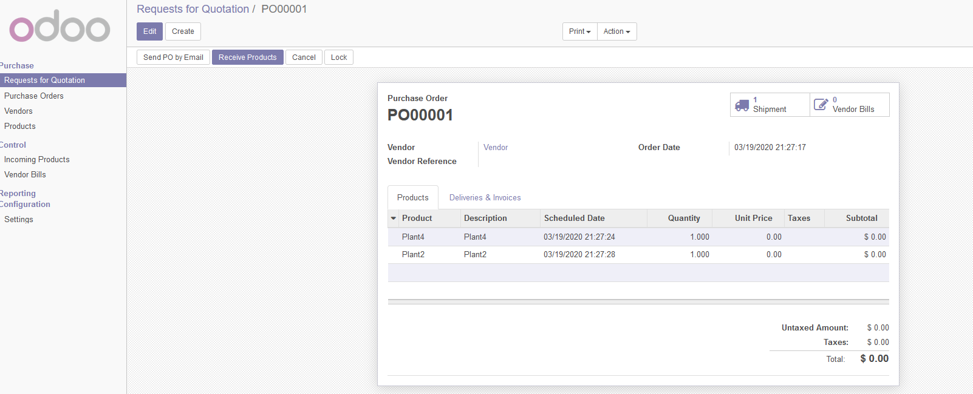

Figure 8 - Purchases module

## Sales module

This module works very similarly to the purchase module, only this is dedicated to the client-company communication. It gathers more information on sold items, tracks the sales and has tools for order invoicing. The module is useful to the company, as the plant shop needs to have good overview on the progress of the main purpose that the company has – sell products.

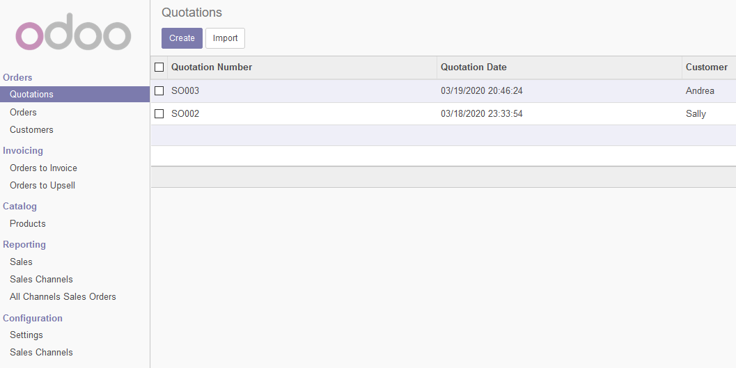

Figure 9 - Sales module

## Website and eCommerce modules

The website builder module allows an easy way to create an appealing website and have it set up to work with all other modules mentioned before. It has a variety of tools that provide information on orders made on the website, abandoned carts, customers that visit the site, products that are sold and reporting on sales.

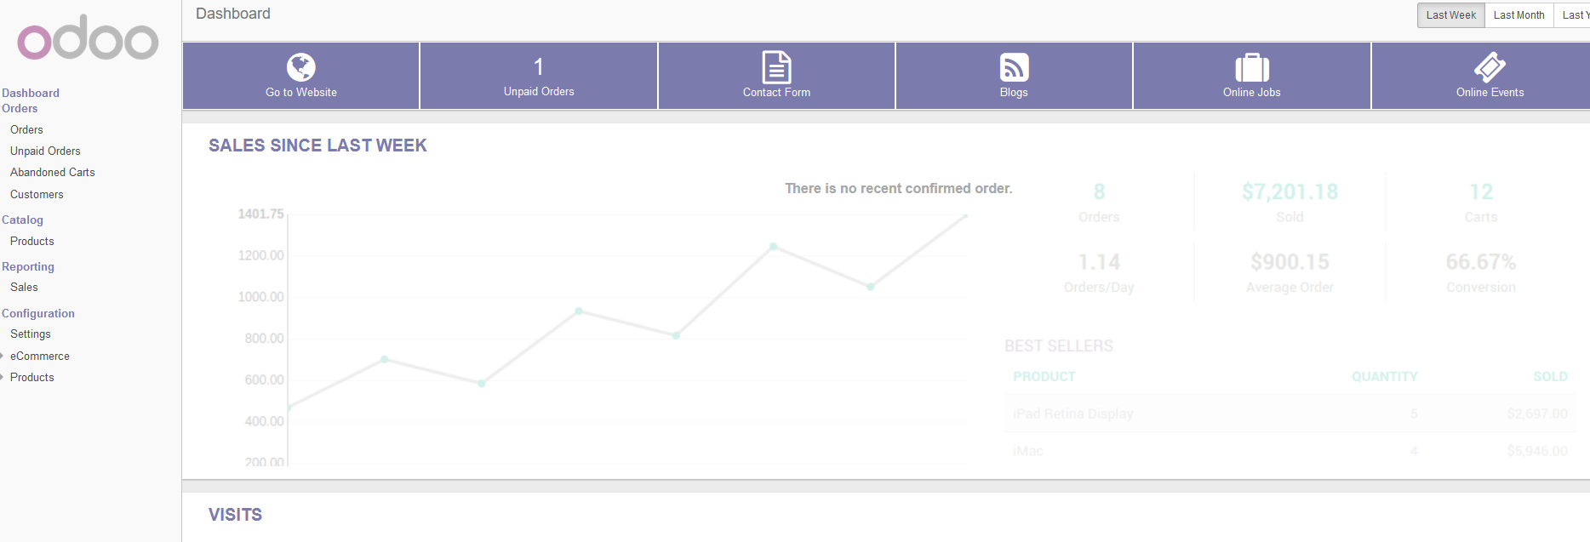

Figure 10 - Website and eCommerce module 1

The drag & drop feature of website creation allows users with no web development knowledge to end up with a compelling view.



Figure 11 - Website and eCommerce module 2

The eCommerce modules provides a variety of payment acquirers as well as a way to purchase the desired products.

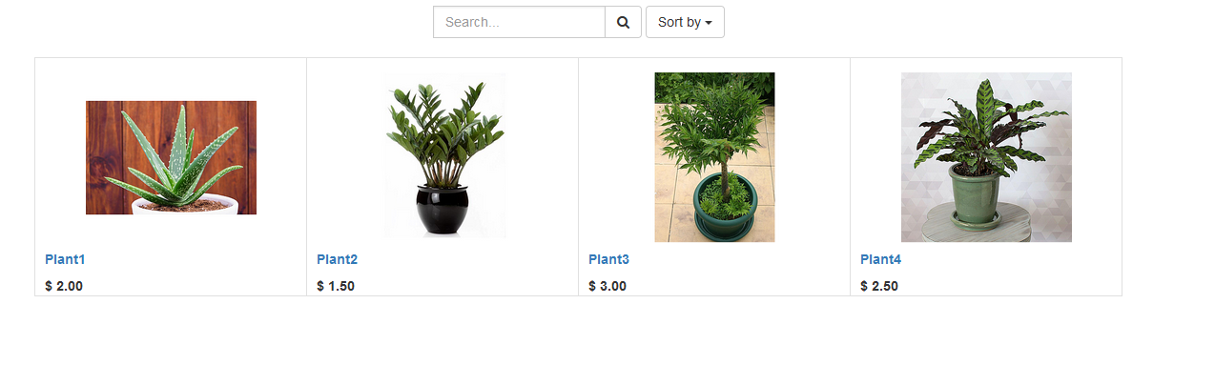

Figure 12 - Website and eCommerce module 3

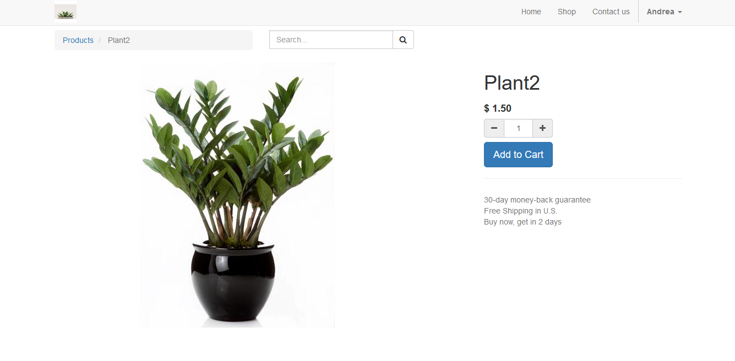

Figure 13 - Website and eCommerce module 4

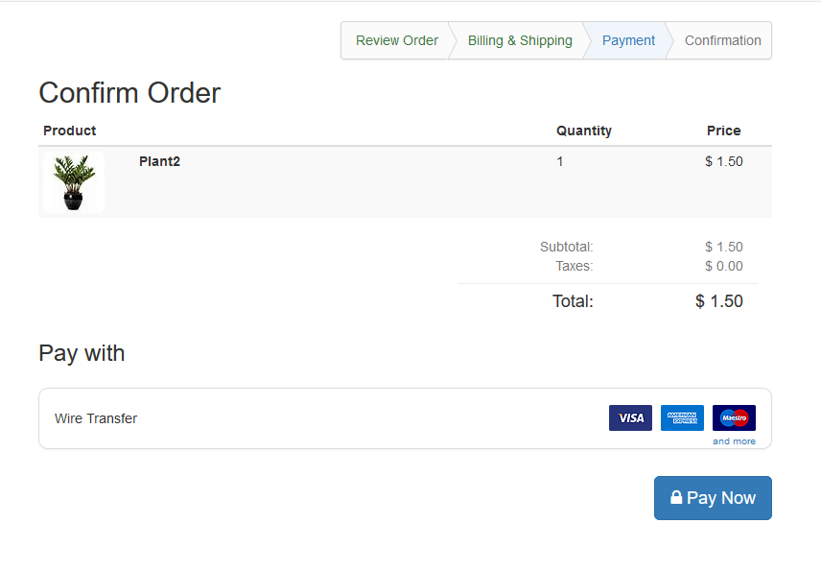

Figure 14 - Website and eCommerce module 5

These modules are essential to have the shop be accessible to the wide public in this day and age, as well as a safe and reliable way of making appealing and working environments for clients to explore and utilize.

# Configured odoo modules

|  |  |  |
| --- | --- | --- |
| **ODOO module** | **What is configured** | **Comment** |
|  | Provided a choice of currency | Allowing a choice of currency provides an easier understanding of price in different regions of the world. |
|  | Changed provider currency and price lists | Different providers may have different currency and price lists, by configuring the provider info, it makes the order change to accommodate the specifications of the chosen vendor and the users can choose the most appealing one. |
| Settings | Users can change the language and time-zone. Rules have been applied to users who are not administrators. | People live in different areas and have preferences to different languages, this means that allowing them to choose their preferred settings provides better user experience. Rule restrictions allow better security in the system. |

## Invoicing Management changes

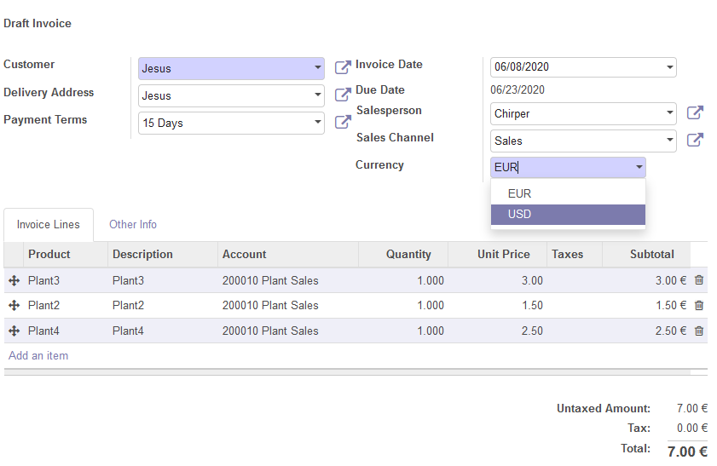

Figure - Choice of currency in invoicing

## Purchase Management changes

Provider currency – on quotation request user can change provider currency.

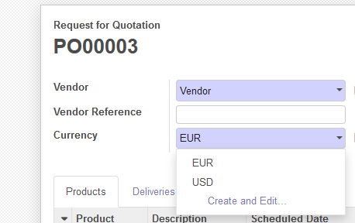

Figure - Currency options

Provider price list allows to change default pricing for the vendor.

Figure - Provider price list

## Settings changes

Language change – users can select whether they want English or Lithuanian version of the system.

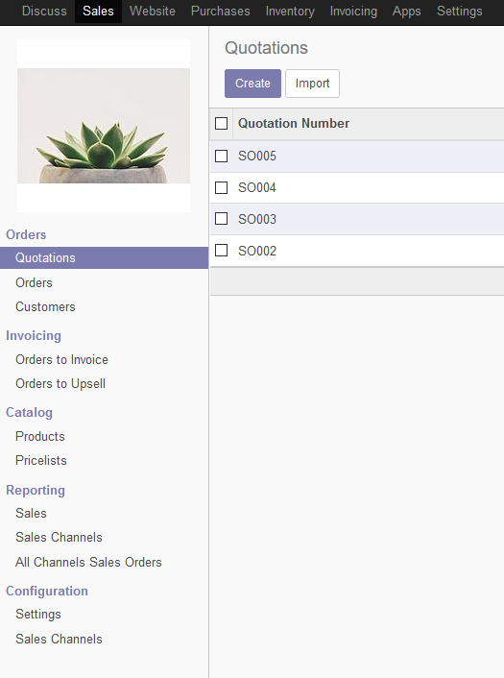

Figure - English version

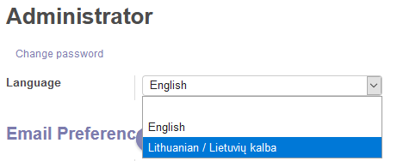

Figure - Language change options

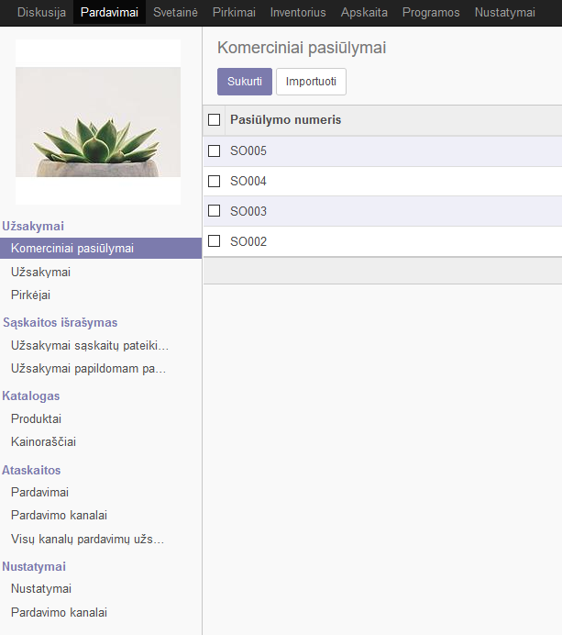

Figure - Lithuanian version

Time-zone changes – user can select the time-zone they are in.

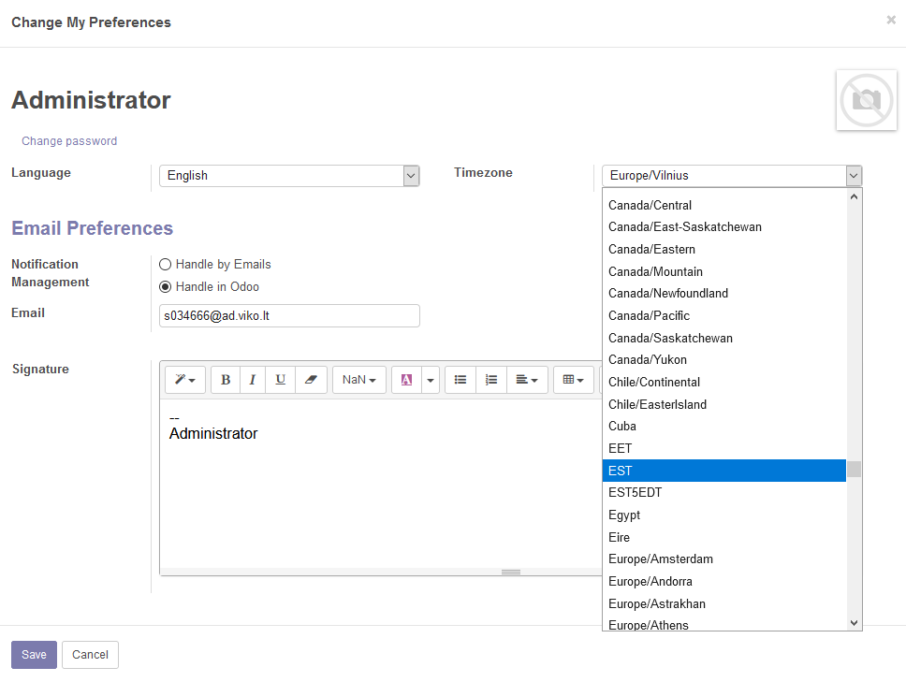

Figure - Time-zone option

Rules for other users – users who do not belong to administrators have access only to personal data.

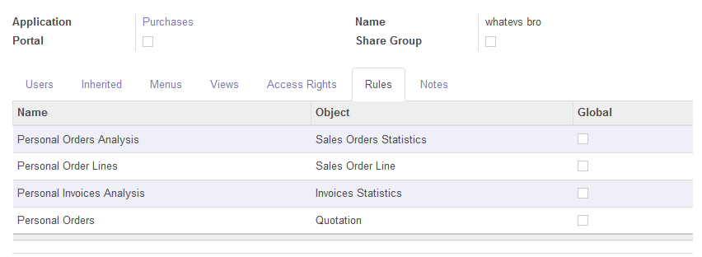

Figure - Rules

# Conclusion

Using business management system, such as Odoo, in this case, saves a lot of time and money for the company when it needs to implement a highly automated, user friendly and convenient computerized system that would link multiple departments to the same database. In this case, for plant shop, the used modules were:

1. Inventory management.
2. Sales management.
3. Invoicing management.
4. Purchase management.
5. Website builder.
6. eCommerce.

By using only a few selected modules and not the entire module package that Odoo provides we reduce implementation cost to the plant shop system, and we do not overload it with unnecessary modules.

Configured modules allow customization in language and time-zones from user point of view, providing better experience with the system. The choice of currency during purchase directly modifies the amount of money that is received or payed out.

In the end, implementing computerized business logic in this way is easier, allows real-time access to the data and provides a wide functionality from pre-made modules.